FACULTY PROFILE
N.KASTHURAMMA.CONTRACT LECTURER IN COMMERCE, M.COM,
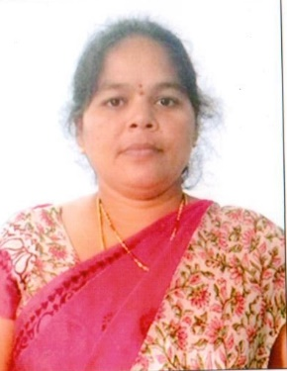
NAME : | KASTHURAMMA NELAMALLI
DESIGNATION : | CONTRACT LECTURER IN COMMERCE
DEPARTMENT WORKING : | EDUCATION DEPARTMENT
SUBJECT : | COMMERCE
COLLEGE : | SMT.N.P.SAVITHRAMMA GOVERNMENT DEGREE COLLEGE FOR WOMEN,CHITTOOR DISTRICT.A.P
DATE OFBIRTH : | 15/05/1983
FATHER NAME : | N.LAKSHMAIAH
MOTHER NAME : | N.SUBBAMMA
CATEGORY : | BACK WARD -HINDU
NATIONALITY : | INDIAN
WORKING ADDRESS : | LECTURER IN COMMERCE  Smt.NPS GOVERNMENT DEGREE COLLEGE FOR WOMEN,CHITTOOR,  CHITTOOR DISTRICT-517002  A.P
PERMANENT ADDRESS : | DOOR NO 8-101,  BUNGAVARI PALLI (VILLAGE),SOMALA(POST&MANDAL),CHITTOOR DISTRICT-517257.
MOBILE NO : | 9492067954
E- MAIL ID : | Kasthuramma05@gmail.com

EDUCATIONAL QUALIFICATION
QUALIFICATION | MONTH/YEAR OF QUALIFYING | COURSE | SCHOOL/COLLEGE/  UNIVERSITY | CLASS / GRADE | TOTAL MARKS | PASS PERCENTAGE
Tenth | JUNE/1999 | Board of Secondary Education | P.J.N. Girls Highs School,Vakadu. | First | 384/600 | 64%
Intermediate | JUNE/2001 | Board of Intermediate  (CEC) | S.P.W Jr College,Tirupati.Chittoor (district). | First | 649/1000 | 64.9%
Graduatio | JULY/2004 | University Board  (B.Com) | S.P.W Jr College,Tirupati..Chittoor (district). | First | 967/1500 | 64.46%
Post Graduation | September/2006 | Sri Venkateswara University  (M.Com) | B.T College,Madanapalli,Chittoor (district). | First | 1679/2500 | 67.1%

JOB PARTICULARS
 | Appointed by RJD | Name of the College | Date of Joining | Total Experience
1 | Appointed as Contract lecturer | Govt. Degree College, Kuppam | 01.11.2008 | 14 years 2 months
2 | Transferred from GDC Kuppam to PVKN Govt College,Chittoor | PVKN Govt College,Chittoor | 24.01.2013 | 14 years 2 months
3 | Transferred from PVKN Govt College,Chittoor To SWRGDC(W),Kalikiri | Smt.N.P.Savitramma Govt for Women. Degree College, Chittoor | 20.07.2015 | 14 years 2 months
4 | Transferred fromSWRGDC(W),Kalikiri To Smt.NPS Govt.College,Chittoor | Smt.N.P.Savitramma Govt for Women. Degree College, Chittoor | 06.08.2018 | 14 years 2 months

SEMINARS

1 | 2013 | UGC Sponsored National Seminar on “Impact on Micro finance and SHGs and Bank Linkage Programme on Rural Women on 28th 29th Dec,2013, PVKN GDC, Chittoor.  Paper: Impact on Micro finance on SHGs and Bank linkage

